University of Pittsburgh at Johnstown
Department of Electrical and Computer Engineering
EE 1195 / COE 1195 Engineering Practice and Professional Development
Time Schedule

Cycle Statistic Tool

Date: November 24th, 2020

Submitted By: Jacob Hoffman
Cody Klingler

Instructor: Professor Gabany
Introduction:
The Cycle Statistic Tool is a data recording device which will be attached to the frame of a bicycle. In this position, several electronic components may be used to record statistics about a user’s cycling trip. The Cycle Statistic Tool will transmit data to a companion application that is installed on a user’s smartphone. This app will utilize the collected information to provide records of a user’s cycling sessions in the form of graphs and charts that enable the user to improve their cycling skills.
The purpose of this document is to divide the project into manageable tasks and then create a time schedule that enables the project to be finished by the appropriate deadline.

Work Breakdown Structure:
The work breakdown structure (WBS) is a decomposition of required work for completing the Cycle Statistic Tool. The WBS will consist of a hierarchical breakdown of the project into primary groupings. Each grouping will contain relevant tasks that are required for the development of the project. The WBS is a precursor to the detailed project schedule and assists in effective time scheduling.

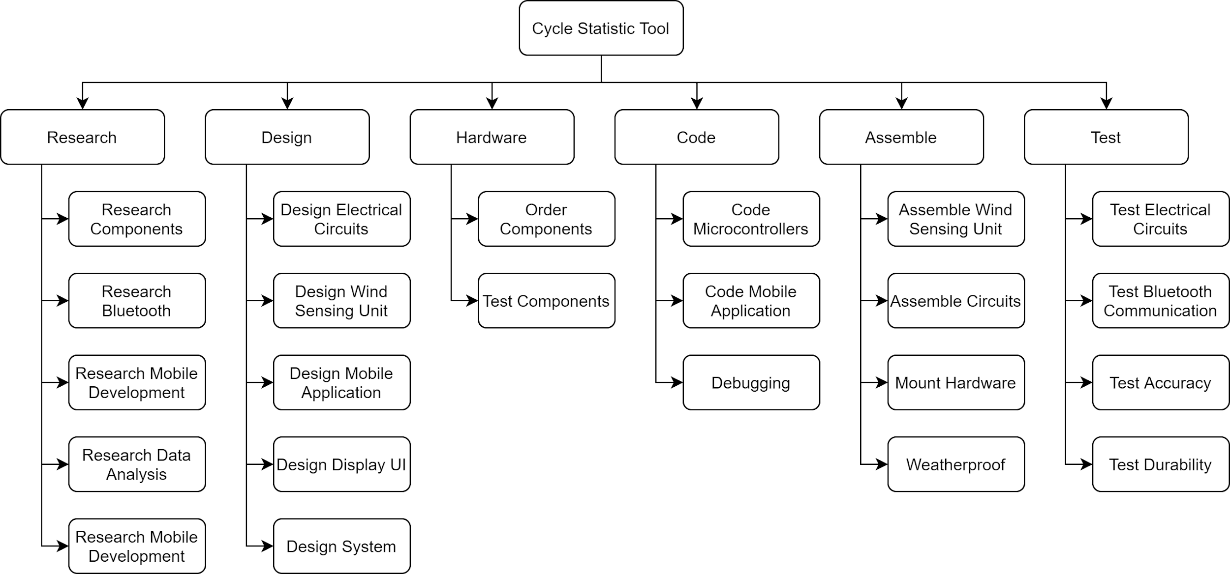
Figure 1: Work Breakdown Structure
Time Scheduling Worksheet:
The time scheduling worksheet accurately estimates the required time to complete each task for the Cycle Statistic Tool. The time scheduling worksheet utilizes the following three estimate points: Optimistic, Pessimistic, and Realistic. The three estimate points represent the shortest, longest, and actual estimated periods of time for completion, respectively. The equations in figure 2 provide equations for calculating the actual time (mean) and uncertainty variance based on the three estimate points.

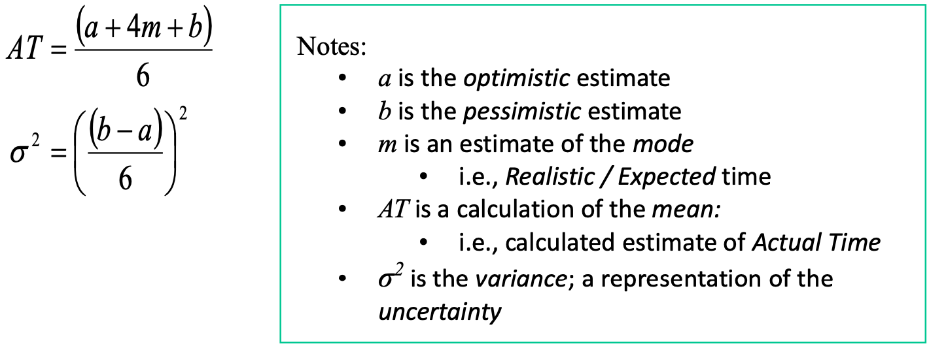
Figure 2: actual time and uncertainty variance equations

Table 1: Time Scheduling Worksheet
Task Description | Optimistic | Pessimistic | Realistic | Actual | Variance
Research Components | 4 | 8 | 6 | 6 | 0.4
Research Bluetooth | 2 | 8 | 6 | 6 | 1.0
Research Data Collection | 2 | 10 | 6 | 6 | 1.8
Research Data Analysis | 2 | 10 | 6 | 6 | 1.8
Research Mobile Development | 6 | 12 | 10 | 10 | 1.0
Design Electrical Circuits | 4 | 10 | 6 | 6 | 1.0
Design Wind Sensing Unit | 6 | 14 | 8 | 9 | 1.8
Design Mobile Application | 6 | 12 | 8 | 8 | 1.0
Design Display UI | 2 | 8 | 4 | 4 | 1.0
Design System | 4 | 8 | 6 | 6 | 0.4
Order Components | 1 | 4 | 2 | 2 | 0.3
Test Components | 8 | 16 | 12 | 12 | 1.8
Assemble Circuits | 6 | 18 | 10 | 11 | 4.0
Code Microcontrollers | 30 | 60 | 40 | 42 | 25.0
Code Mobile Application | 30 | 60 | 40 | 42 | 25.0
Debugging | 30 | 60 | 40 | 42 | 25.0
Assemble Wind Sensing Unit | 8 | 20 | 12 | 13 | 4.0
Mount Hardware | 8 | 16 | 12 | 12 | 1.8
Weatherproof | 2 | 4 | 3 | 3 | 0.1
Test Electrical Circuits | 6 | 25 | 20 | 19 | 10.0
Test Bluetooth Communication | 2 | 10 | 5 | 5 | 1.8
Test Accuracy | 8 | 24 | 12 | 13 | 7.1
Test Durability | 4 | 10 | 6 | 6 | 1.0
Total Hours | 181 | 427 | 280 | 288

Network Diagram:
The network diagram combines the task requirements from the WBS with the estimated times from the time scheduling worksheet. The critical path method is used to determine the most efficient timeline for finishing the project. The critical path, which is the longest path through the network, is highlighted within the network diagram.

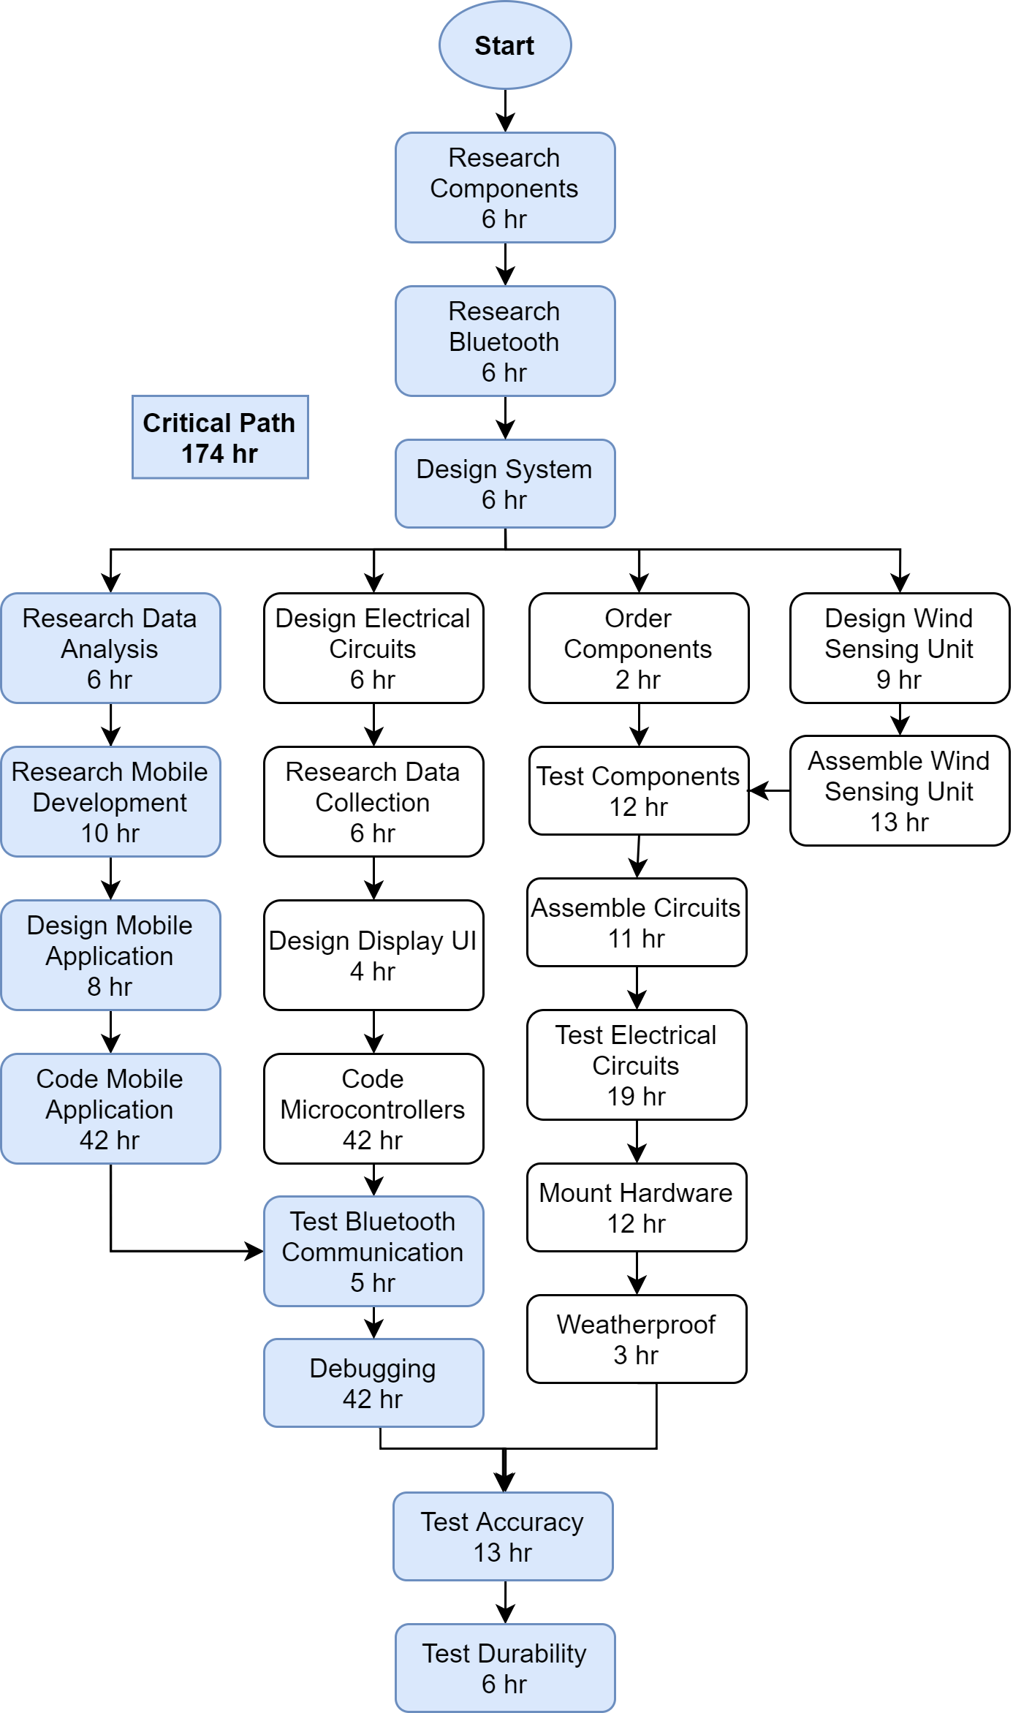
Figure 3: Network Diagram
Task Division:
The task division table provides appropriate start and end dates for each task to complete the Cycle Statistic Tool within the appropriate time frame. The task scheduling sheet and network diagram are used to determine the selected dates. The division of labor between project members is indicated in the table. The task division table is a precursor for the GANTT chart.

Table 2: Task Division Table
Task Description | Duration | Start Date | End Date | Member Responsibility
Research Components | 6 hrs | Sat 1/2/21 | Mon 1/4/21 | Both
Research Bluetooth | 6 hrs | Mon 1/4/21 | Fri 1/8/21 | Both
Design System | 6 hrs | Fri 1/8/21 | Sat 1/9/21 | Both
Research Data Analysis | 6 hrs | Mon 1/11/21 | Wed 1/13/21 | Jacob
Research Mobile Development | 10 hrs | Wed 1/13/21 | Mon 1/18/21 | Jacob
Design Mobile Application | 8 hrs | Mon 1/18/21 | Fri 1/22/21 | Jacob
Code Mobile Application | 42 hrs | Fri 1/22/21 | Wed 2/10/21 | Jacob
Design Electrical Circuits | 6 hrs | Mon 1/11/21 | Wed 1/13/21 | Cody
Research Data Collection | 6 hrs | Wed 1/13/21 | Fri 1/15/21 | Cody
Design Display UI | 4 hrs | Wed 1/13/21 | Fri 1/15/21 | Cody
Code Microcontrollers | 8 hrs | Fri 1/15/21 | Mon 1/18/21 | Cody
Test Bluetooth Communication | 5 hrs | Wed 2/10/21 | Fri 2/12/21 | Both
Debugging | 42 hrs | Fri 2/12/21 | Wed 3/3/21 | Both
Order Components | 2 hrs | Mon 1/11/21 | Mon 1/11/21 | Cody
Test Components | 12 hrs | Wed 1/20/21 | Mon 1/25/21 | Cody
Design Wind Sensing Unit | 9 hrs | Mon 1/11/21 | Fri 1/15/21 | Both
Assemble Wind Sensing Unit | 13 hrs | Fri 1/15/21 | Wed 1/20/21 | Cody
Assemble Circuits | 11 hrs | Wed 1/27/21 | Sat 1/30/21 | Cody
Test Electrical Circuits | 19 hrs | Mon 2/1/21 | Mon 2/8/21 | Cody
Mount Hardware | 12 hrs | Wed 2/10/21 | Mon 2/15/21 | Both
Weatherproof | 3 hrs | Mon 2/15/21 | Mon 2/15/21 | Both
Test Accuracy | 13 hrs | Fri 3/5/21 | Wed 3/10/21 | Both
Test Durability | 6 hrs | Wed 3/10/21 | Fri 3/12/21 | Both
GANTT Chart:
The GANTT chart is a graphical representation of the task division. The duration of time for each task is displayed. The GANTT chart ensures that each task for the Cycle Statistic Tool is completed on time.
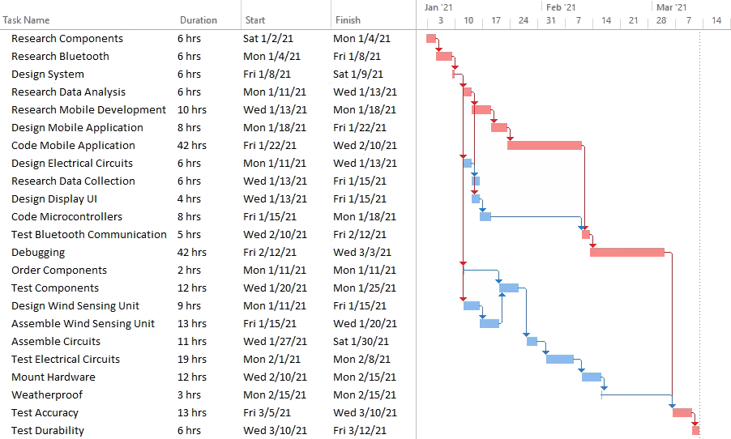
Figure 4: GANTT Chart

Conclusion:
The time schedule document provides an accurate representation of the time duration for completing each development task of the Cycle Statistic Tool. Additionally, a timeline for task completion is generated, which enables the project team to properly manage the flow of events for completion of the Cycle Statistic Tool.

